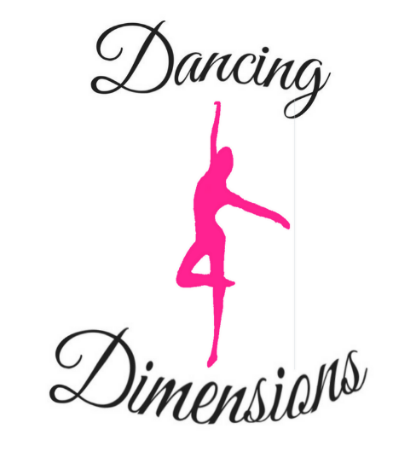

Dancing Dimensions School of Dance Consent Form

Student Name_________________________________________

Details of Required Permission Signature

To gain full potential, it is sometimes necessary
for the teacher to have physical contact with the student.
Please sign to consent to this:

Please do not bring your child if they are feeling unwell or show any symptoms
Of Covid 19.

Permission to photograph or film to support the students
Individual development.

If the student requires medical treatment
I authorise Dancing Dimensions staff to seek and enable.
this treatment.

I give permission for the student to be photographed during
Class time and have their photos posted on the Dancing Dimensions
Facebook page/social media.

Permission to include images of the student on the dancing dimensions
Website/advertising.

Emergency Medical consent

In the event of an emergency, should the teacher or representative of Dancing Dimensions consider it necessary, I agree for an ambulance to be called for the above student.

I have read the safeguarding policy, policies and procedures.

Name

Sign
Date

